You can access data from BigQuery: gdelt-bq.full (google it)

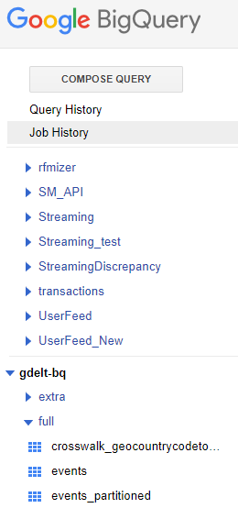

1. Find list of all pairs of actor names (not blank) with number of events higher than 30 in descending order. Look at one day 2017-10-01

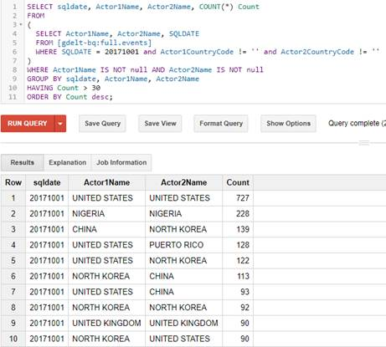

1. Find place with highest number of mentions separately for good and bad events. Return two rows.
   1. 20171001
   2. Latitude and longitude are not equal zero, rounded to one decimal point
   3. QuadClass <= 2 means good event, QuadClass >= 3 means conflict

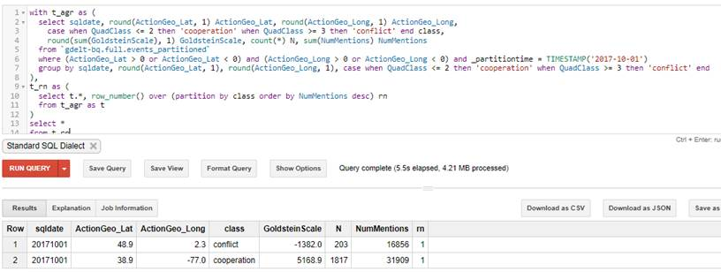

1. Retrieve all urls with the highest GoldsteinScale rounded to one decimal point per each Actor1Name  (there might be more than one row)
   1. 20171001
   2. Actor1Name is not null

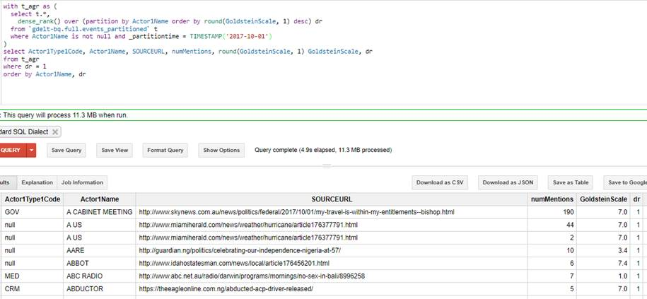

1. Extract top list of counties with meta data (capital, population, area, currency)  according to number of articles
   1. To get country info **join** table gdelt-bq.extra.countryinfo

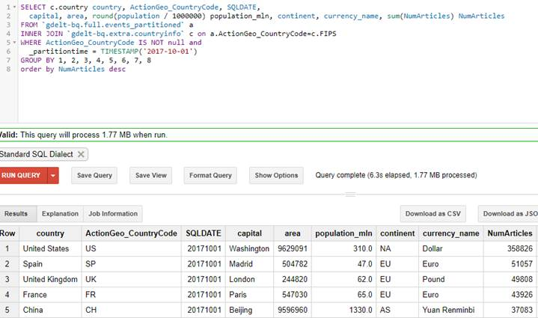

1. For each country find out the longest distance between two event points
   1. 20171001
   2. ActionGeo_CountryCode is not null
   3. Join country info

